Steps to run Messaging Service Prototype-

1. ensure Node.js is installed on your laptop.
2. clone the repository using Git and Navigate to the project directory
3. Now install dependencies-

npm install

npm install express

Node.js is used for runtime environment that allows to run JavaScript on the server

We install npm , it is the package manager for java script. It has used to download and install project-specific package, libraries.

I used Socket.io, it enable real-time, bidirectional communication between the server and client. It allow user to send and receive messages in real time.

1. Now type **node server.js**

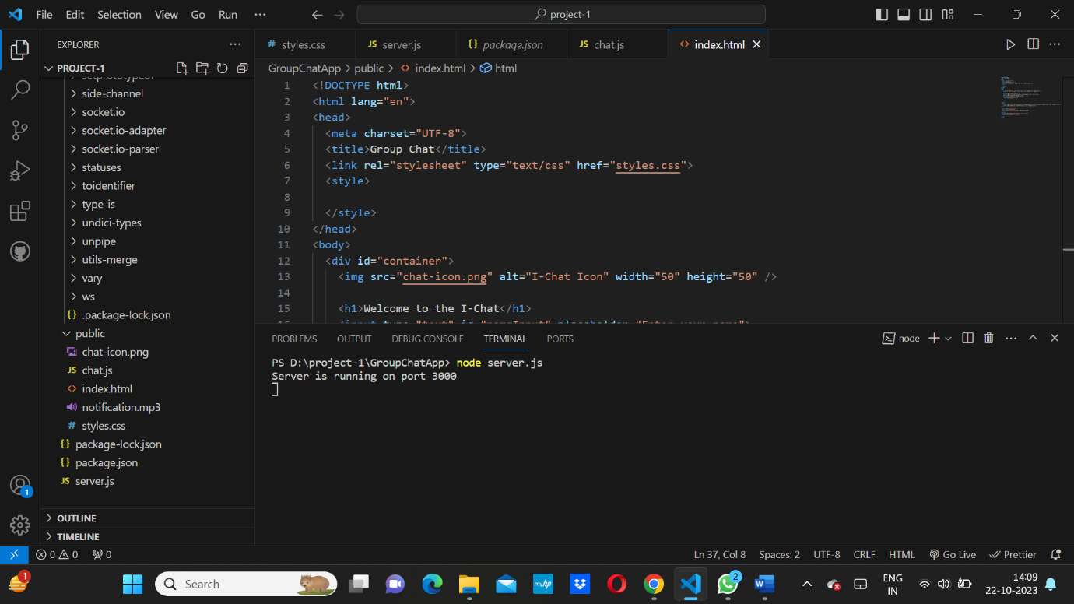

1. Once the server is running the we can access that chat application in a web browser by navigating to:

[**http://localhost:3000**](http://localhost:3000)

The interface will look -

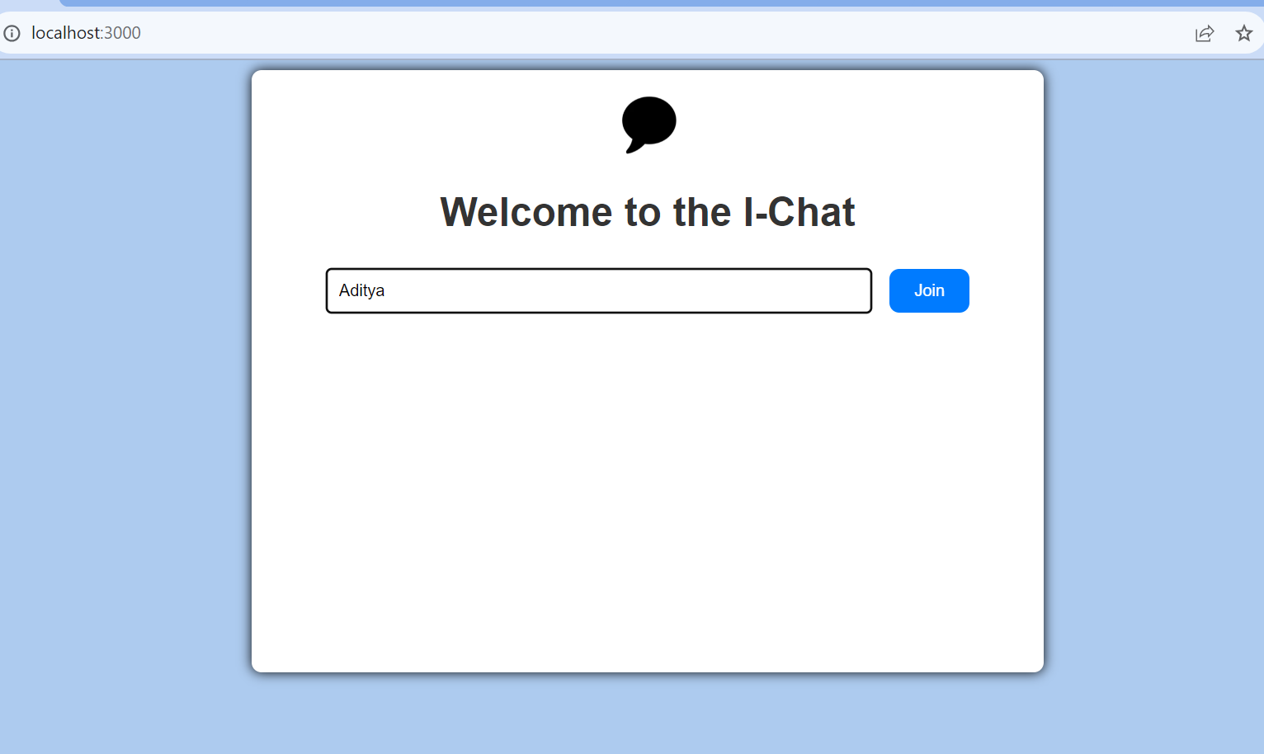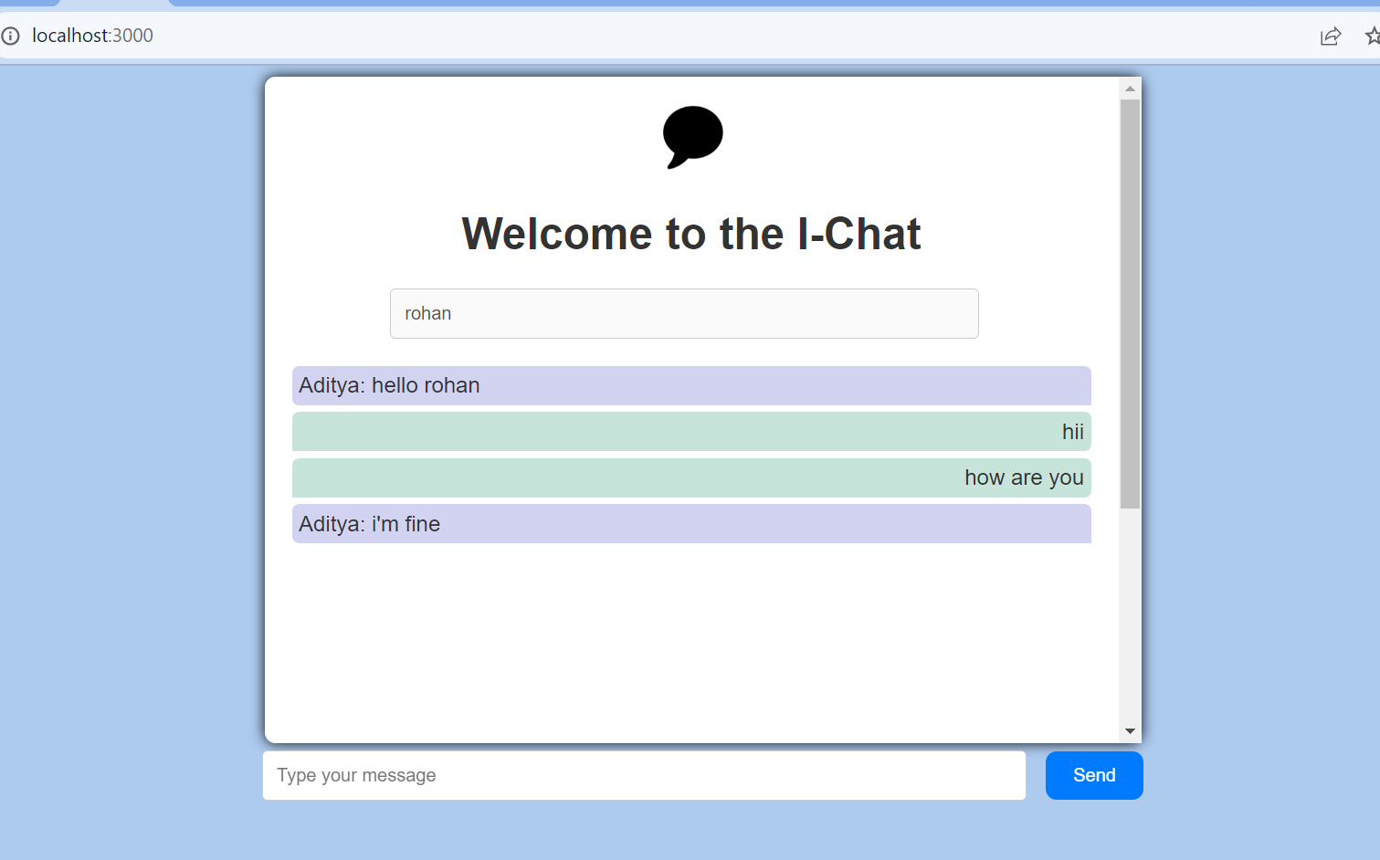

* Feature of this chat application-

1. Very easy to use , with a good interface
2. Multiple user can join the chat at a time, it is capable of handling that.
3. Message got updated in real time , without refreshing the page.
4. It give a notification sound , when a user receive message.
5. User message are shown on right, and received message on left.